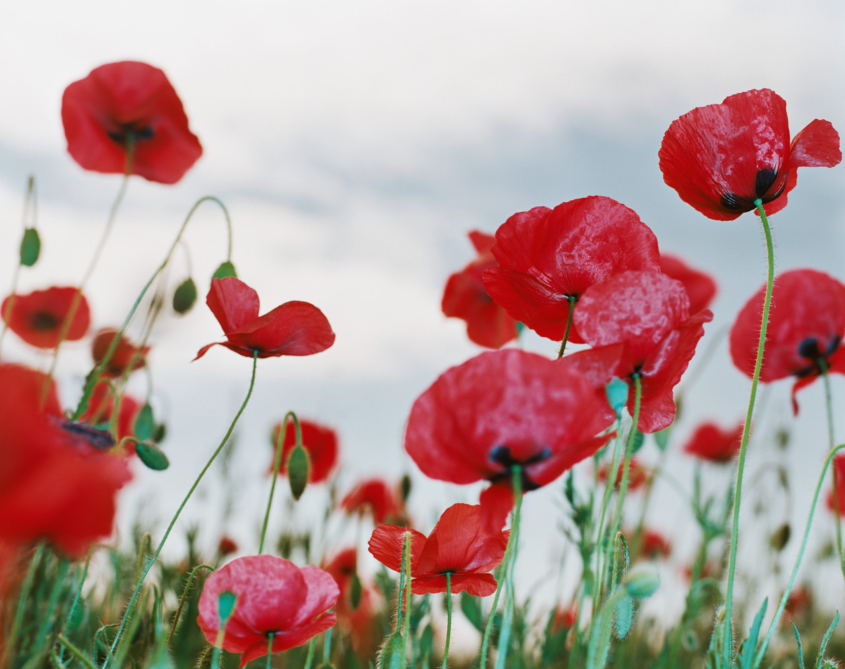

POPPY APPEAL COFFEE MORNING 2013

LADY RICKETTS, wife of H.M. Ambassador to France

Has kindly accepted to host a Coffee Morning

In aid of the Poppy Appeal

Which the ROYAL BRITISH LEGION, PARIS BRANCH

Organizes every year for the benefit of the

EARL HAIG BENEVOLENT FUND

The Coffee Morning will take place at

THE BRITISH AMBASSADOR’S RESIDENCE

39 rue du Faubourg St. Honoré,

Paris 8eme

TUESDAY, 29th OCTOBER, 2013

10h30 - 12h00

Please send your stamped addressed envelope to :

Miss Joan Hicks,
6 rue des Petits Prés,
78810 FEUCHEROLLES
01 30 54 33 06/06 19 17 34 48
Please Print your Names clearly

An invitation card for presentation at the entrance will be sent to you. This is a Charity event, please give generously. All donations welcome. I.D. Cards or Passports required. Numbers are limited. Date limit for applications 25/10/2013

